AI Regions

Introduction

This document discusses the use of AI Regions to ensure that overlapping Nav Meshes on different levels of a map do not interfere with each other. In the office area of the Church_02 map it was noticed that sometimes enemies on the second floor would fall through the floor and end up on the first floor. We never figured out exactly why this happened, but did notice that the separate Nav Meshes for each floor overlapped. In FEAR maps with catwalks that have Nav Meshes overlapping the floor Nav Mesh Monolith enclosed each Nav Mesh in a separate region. When we enclosed each floor of the Church office in a separate region then enemies stopped falling through the floor.

Tutorial example

A sample level with Nav Meshes on the floor and balcony that overlap is AI_Regions01. Both these Nav Meshes are enclosed in a separate region. The enemies that spawn on the balcony remain there and do not fall through to the ground.

Figure 1 shows a picture of the level as seen in the level editor. There are two Nav Meshes in use. A mesh on the upper balcony level (A) allows the enemies to move around the platform. The second Nav Mesh (B) covers the floor and a small raised platform. AINavMeshLinkJump objects (C) connect the balcony and floor meshes, and connect the platform and ground sections of the floor Nav Mesh. Each Nav Mesh is covered in its own region, and the regions do not overlap. The jump links that leads from the balcony to the floor go into two regions, but jump and stair links intersecting regions does not seem to matter.

It is still unclear what causes soldiers to use Nav Meshes on different levels and run off balconies or fall through the floor. In this tutorial level, if you remove the regions the soldiers never appear to fall through the balcony anyway, so its uncertain exactly when enclosing Nav Meshes in separate regions is necessary. There are some issues that are not completely understood, and these are listed here.

- It is uncertain how high the region brush surrounding the Nav Mesh should be. Whether the region needs to be large enough to cover a person standing in it (300 cm), or can simply cover the Nav Mesh itself (30 cm high) is unknown. I always make sure the region is large enough to cover any one standing in it, but I’m not sure this is necessary.
- Separating Nav Meshes on different floors with regions seems to work well with soldiers, but in the Hospital_01 level Assassins appeared to run through a door and into a region with no Nav Mesh on the floor – it was using the Nav Mesh from another floor even though it was in a different region.

Figure 1: View of AI_Regions01 as seen in the level editor.

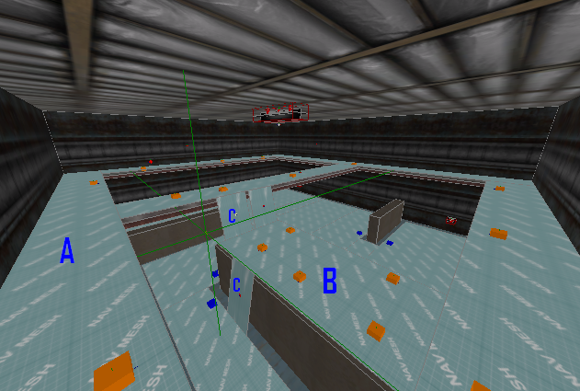

The regions are not shown in Figure 1. The top region extends from the bottom of the balcony and has a height of 320cm, while the floor region extends from the floor to 30cm above the Nav Mesh on the platform. There is a 130cm gap separating the regions.

Notes on the Jump Links in AI_Regions01

While building AI_Regions01 there was trouble getting the AINavMeshLinkJump objects (C in Figure 1) to work properly. The comments here should ensure that the Jump Links work properly.

The AINavMeshLinkJump contains two smart objects that are used by soldiers, JumpDown and JumpRail. The JumpDown smart object has the character play a “hopping down” animation at the link and is useful for moving from one level to another when there are no obstacles (like railings) in the way. The JumpRail smart animation has the soldier play a “leaping over a rail” animation, and is used for jumping over walls or rails that are 100cm high.

To ensure that the jump link works properly make sure of the following:

- There should be no portion of a Nav Mesh underneath the Jump Link.
- Make sure that the Nav Mesh where the soldier starts the jump from does not extend beyond the platform. This is especially critical for the Jump down smart object. In one map the Nav Mesh where the jump started was accidentally extended 20cm beyond the edge of the platform. When using the Jump Down object the soldier would frequently fall through the floor, but this never happened with the Jump rail smart object. When the Nav Mesh was made even with the ledge soldiers never fell through the floor.

